**FSW-100**

**Career Readiness Task #1: Professional Communication**

This is the first of five tasks in your Career Management milestone to earn your Career Ready badge. This task consists of two parts: written and oral communication. You’ll need to complete both parts to finish this assignment. Don’t worry – this isn’t just another assignment. Consider it real-world training to get you ready for the workforce! After you’ve completed both the written and oral parts be sure to save and upload this worksheet to Portfolium on the assignment page where you downloaded this document.

**Part 1: Showcase your Professional Written Communication Style**

Read the examples below and edit and revise them so that they are written professionally. Use the boxes below to complete this assignment.

1. Email to your manager requesting time off:

hey adrian i need thiz thurs & fri of. i totes need a break from werk. 😊 thx-alexa

Rewrite this example here:

Hello Adrian, I would like to request Thursday June 28th and Friday June 29th off work. Please let me know if this is approved. Thank you Alexa.

1. Email to a coworker who likes their information short and sweet:

Hey Alan, how are you? I’m good. My weekend was soooo much fun. I totally need a weekend from my weekend….if you know what i mean!!!!!!!!!!!!!!!!!!!!!!! i need yur help w/ a project. Its totally taking up toooooooooooooo much of my time. For example I dont know what jen wants and I feel like its way to much to tell me to do. I mean its Monday!!!!!! If ya want ta get some coffee I’m soooo ready for a break & some cool catchin up. BTW-the project is supposed to bee about writing a sales pitch to a client we sorta want to grab. Anyways ,ttl.

Rewrite this example here:

Hi Alan, Can you assist me with writing a sales pitch for a potential client? Jen assigned this task to me and I am unsure of how I should handle the task. Thanks for any assistance that you can provide. -Alexa

1. Request to a former boss asking for a reference (tip: include examples of your past work to help jog her memory and a deadline to spur her along):

Dede – hey! Long time no talk. I’m sure you’re busy and so am I! I am going for a new job and wanted to see if you can write me a super quick letter of reference. You were awesome to work for last year but now I’m tryin to move on to bigger and better thingz! Thanks so much!!

Hello Dede, My name is Natalie Jones and I worked on the “Caswell project” that closed at 25% higher than what the company expected. That was a great project to work on and I really enjoyed the team work. I wanted to ask you for a letter of recommendation for a new job position that I would like to apply for on this Friday June 29, 2020. I am looking to enhance my career skills so that I can grow within the company. Please let me know if this is something that you would be able to assist me with and Thank you so much. – Natalie Jones (Supervisor of Market Media)

1. Follow up email from a face-to-face department meeting:

You just attended a staff meeting where you are collaborating on several projects with teammates. While you all “agreed” or at least nodded your heads when it came time to decide on milestones and deliverable deadlines you want to be sure you are all on the same page. In the space below write your follow-up email to your teammates that includes a summary of what you discussed and the milestones that you all “agreed” upon in your face-to-face meeting.

To get you started here are some sample milestones and dates:

* New client push – need to reach out to at least 5 new clients by March 5.
* New client sign-on – need to have at least 3 new clients signed on for business by March 31.
* New client website draft #1 due by April 30
* New client website launch date May 31

Meeting Notes from January 20th, 2020

Hello Team, The following notes are from our recent team meeting on January 20th, 2020. Please note that everyone is required to reach out to 5 new clients by March 5th, 2020 and sign on at least 3 new clients by March 31st, 2020.

New client website draft is due no later than April 30th, 2020.

The new client website will launch on May 31st, 2020.

Please contact your direct supervisor if you need further clarification or if you need any additional information.

Have a great day team.

**Part 2: Web Development Oral Presentation**

You are working on a web development team and now it’s your turn to present your code to the team. Recall the tips for professional oral communication as you take any one of the coding projects you completed in this course and explain the following in a 1- to 3-minute presentation:

* Webpage Components
  + Show your webpage to your colleagues so they can see it on-screen.
  + Explain the business you built the website for.
  + Explain the different elements you included (image, table, etc.).
* Webpage Code
  + Briefly explain the html code you used discussing the main parts of it (e.g. navbar, header, main, footer, image, table, etc.).
  + Briefly explain the CSS code you applied to style parts of the webpage (e.g. color, font, responsiveness).

**Note**: You don't have to explain everything you did, just discuss 3 styles you applied.

Practice your presentation before you record it. Then, present your project in a 1-3 minute presentation.

**How to Create and Submit this Video Screencast:**

1. From your local machine, open your .html file so it opens in your browser as a webpage.
2. Go to Studio found on the left menu of Canvas and record your screencast. Once you launch the recorder, you should choose “**Both**” so that you record both yourself presenting and your screen.

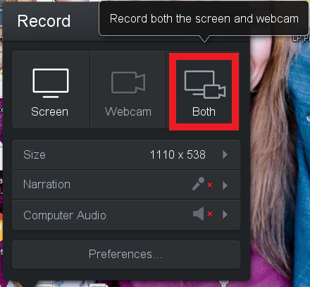

1. Once you’ve uploaded your video, select the video.
2. Select the Share button and copy the Link.
3. Go back to this assignment in Canvas, and click the Start Assignment button toward the bottom of the page.

Upload this completed document. Also click Paste a link to add your Studio URL When the document is attached and URL added, click the **Submit Assignment** button.